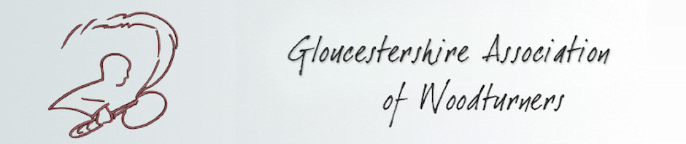
GLOUCESTERSHIRE ASSOCIATION OF WOODTURNERS
SUBSCRIPTION RENEWAL (2018)

Dear Member,

Your GAW membership renewal is due on the 1st January 2018. The subscription fee for 2018 is once again unchanged at £26.00 for Full Members and £13.00 for Full Time Students.
Included in next years programme are Mark Sanger, Dave Appleby and Colwin Way plus we have three all day demonstrations by Jason Breach, Les Thorne and Sue Harker.
To renew your membership please complete both pages of this Renewal Form and either –
Bring them along to a club night with your payment (cash or cheque made payable to G.A.W.) where you can collect your 2018 Membership Badge and Programme
or
Post them to our Membership Secretary along with your cheque (made payable to G.A.W.) to:
Les Cooper, 27 Lilliesfield Avenue, Hucclecote, Gloucester, GL3 3AQ.
Your 2018 Membership Badge and Programme will then be posted back to you.

PLEASE COMPLETE IN BLOCK CAPITALS

Name: ________________________________________ Membership Number: _______________
PLEASE LIST ANY CHANGES TO THE INFORMATION GAW HOLDS ON YOU BELOW.
Address: ________________________________________________________________________
_________________________________________________________________________________
Postcode: ___________________________________

Telephone (Home): ____________________________

Mobile: ______________________________________
Email: ___________________________________________________________________________

Cont ……..

In addition, please take a few minutes to help the Organising Committee by completing the following;

GAW organises hands on training for beginners. Please tick this box if this is of interest to you.

In your opinion how can the GAW improve the club for its members. _________________________
__________________________________________________________________________________________

Do you use the GAW DVD library Yes No

How could we improve this facility ____________________________________________________

Are there any woodturning DVD’s you would like added to GAW library ______________________
__________________________________________________________________________________

What type of demonstrations do you most like to watch –

 | Bowl |  | Spindle |  | Hollowing

 | Involuted |  |  | Carving |  |  |  | Pyrography

 | Colouring |  | Boxes

 | Other, please specify | ____________________________________________________________

Insurance: The GAW holds an insurance policy on behalf of Club members. However, it is the responsibility of all members to ensure the safety of themselves and others whilst attending club meetings and activities whether taking part or watching.

